Specifications

TENT42 - TENT, MULTIPURPOSE, 42m² - Light Weight Frame Hub Tent
General description
42m² multipurpose tent which can be used for storage, hospital, dispensary, school, office, or other activities. Should have a frame with bottom/floor pipe for easy setup on hard floor. It should also possess a good ventilation system and be comfortable in all climates.
The tent:
Should have a minimum shelf life of about 5 years.
Once erected its life span should be at least 1 year
Flame retardant CPAI 84 Section 6 (max. afterflame avg 10s)
It should be disinfected easily , not sensitive to fungi/mould.

should be equipped with a flooring / ground sheet.
Should have a good ventilation system
Available add ons such as the below mentioned should be offered and quoted separately or easy selection. E.g.:
Innerliner
Winterization Kit
Flysheet
Flooring
Partitions

Width: 6.00 m
Length: 7.00 m
Eaves height: at least 2.05 m
Ridge height: at least 2.90 m
Doors: 2 doors (1 each short 7 gable side)
Windows: at least 3 on the long side , 2 on the short side.

Tent skin and flooring:
The outer tent liner should be woven PE 250 gsm - water, rot and UV proof and fire resistance according to CPAI-84 Section 6. The tent liner panels should be a separated roof, gables and wall panels for easy set up and handling.
The ground sheet should be made of woven PE 250 gsm - water; rot and UV proof. It should be bath-tub style with min. 15 cm upstanding sides.
The windows should be 3 layered: roll-up PE flap, fixed mosquito mesh and transparent PVC roll-up flap,
The colors of the materials should be: - tent liner: white and the groundsheet: light grey
Frame
Galvanized steel pipe or aluminium frame

Packaging MEASUREMENTS
DIMENSIONS: 225 x 57 x 72 cm
WEIGHT: ± 240 kg
VOLUME: 0,93 m³

TENT18 – TENT, QUICK UP 3x6m, with logo

Scaffolding
The tent frame should be completely made of anodized aluminum rectangular tubes
with aluminum connectors.
To protect the tent roof from chafing, plastic caps should be attached to all parts and
screws that come into contact with the fabric.
Should be received with the frame completely pre-assembled and only needed to be
pulled apart during assembly.
This is particularly easy with built-in plastic bushings, which also prevent abrasion
marks.
The tubes should snap into place independently. All snap connections should be designed
in such a way that you cannot jam fingers. The legs should ideally be extended in 10 cm
increments, resulting in passage heights of 1.92 m to 2.32 m.
Roof

Tent roof should be made of polyester fabric 550dtex (240 g/m ²) coated on one side with PU;
flame-retardant, waterproof and rot resistant. The roof should connect to the frame by
means of Velcro.
It can remain attached to the scaffold after the initial assembly in dismantled condition and
thus be packed away dry.
The roofs should be white with GRC Logo.

General:
- pre-assembled
- poles completely made of anodized aluminum
- with robust carrying bag
- without side walls
- with scissor-grid folding technology
- min. 6 height adjustable supports
- easy to assemble / unfold by max. 2 persons
- roof on each of the 2 long sides with 1 x GRC logo (details on logo please see below)
floor space = 18m² = 6m x 3m
headroom = adjustable up to min. 2.02m
ridge height = adjustable from min. 3.05m
canvas material / roof = white - 100% waterproof polyester fabric / nylon - UV resistant
Total weight = max 30KG

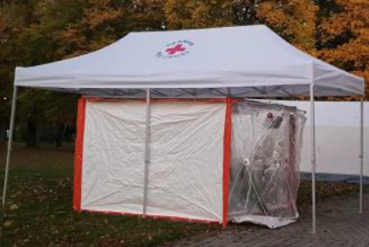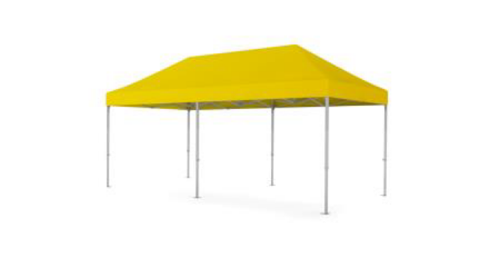

GRC Logo
"German Red Cross" logo English, 800mm
On both 6m sides, in the middle
Thermal transfer printing
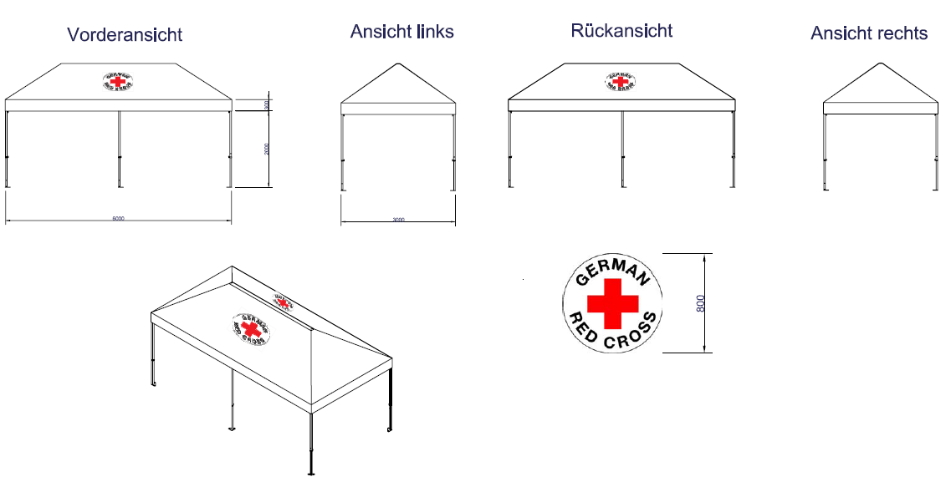

IMPORTANT NOTE:
For packaging requirements see separate attached sheet with detailed instructions

